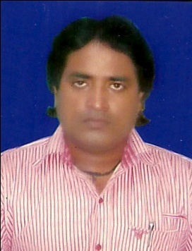
RESUME
RAJIV RAJ RANJAN
Mob:- 9661887434
Batch No.- 3609
C/O Dr. Rekha Sinha ( Cambridge Academy)
Opp. Road No.-2, Gardanibagh, Patna-1
Email Add.- rajivrajranjan22@gmail.com

CAREER OBJECTIVE

- To serve the organization with full dedication and continuously nurture and use my knowledge in the corporate world to make organization at its supreme position.

PROFESSIONAL QUALIFICTION

- Diploma In Computer hardware & networking from Jetking Patna.

EDUCATIONAL PROFILE

Course | Board/ Univ. | Year | Percentage
MLIS | NOU | 2008 | 60%
BLIS | IGNOU | 2006 | 64%
B.A/ (His Hons.) | M.U | 2001 | 54.6%
I.Sc. | BIEC, Patna | 1996 | 46%
Matriculation | C.B.S.E., Patna | 1994 | 54.6%

PERSONAL SKILL

- Hard working with proper Attention & Responsibility, Cool thinking also in Adverse Situation, to finish work at right time.
- To be independent and to have developed the skill of managing your time and work. And also capable of original and creative thought.

STENGTH

- Keen to learn new things and high energy level.
- Having confidence to keep patience in adverse time.

HOBBIES

- Playing Cricket.

PERONAL DETAILS

Father’s Name : Rajan Singh
Date of Birth : 31.12.1978
Sex : Male
Physical aspects : Average build with 5.4 ft.height.
Religious trend : Not a fanatic having belief in other religion
also.
Parental & Economic Status : Belong to middle class family.
Nationality : Indian
Marital Status : Single
Permanent Address : Rajiv Raj Ranjan
S/o Rajan Singh
Vill- Bhiwarpur, P.o- Madhurapur,
Dist.- Vaishali.

DECLARATION

- I hereby declare that all the information above is correct.

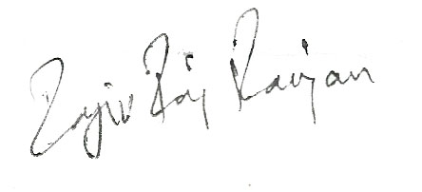
Date: 22.09.11

Place: Patna Signature

